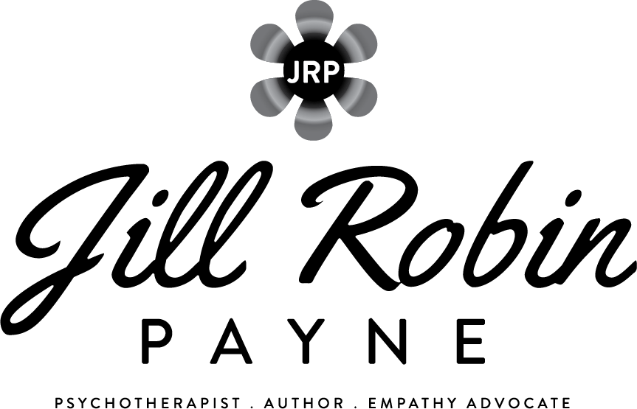

This agreement is made between Jill Robin Payne (“Coach”) and ____________________ (“Client”) on this ____ day of ____, 20__. Both parties agree to the following: ***Coaching is a collaborative*** process with an ongoing relationship between the Client and Coach. The coaching experience supports the Client in establishing new behaviors. The coaching relationship is strengths-based, forward-looking, and collaborative. The coaching agenda is developed and implemented in partnership between the Client and Coach. The role of the Coach is to help the Client progress toward achieving a goal. The Client and Coach agree to engage fully in the coaching experience. ***The Client recognizes that coaching is not therapy, counseling, or consulting***. Confidentiality - The Coach agrees to keep all conversations and information with the Client private and confidential, as allowable by law. No personal information will be shared with anyone without the Client’s express permission. Exceptions may be made if there is an imminent threat of serious injury to oneself or someone else or consulting with other colleagues. Coaching Commitment - By entering into this relationship, the Client and Coach acknowledge that the Client desires to make a behavioral change or some type of improvement in his or her life. Behavioral change often takes time to implement and sustain. The pace of change is uncertain and varies amongst individuals. As such, the Client and Coach agree to a minimum of a 3-month relationshi**p**. Coaching Session Procedures - Coaching sessions may occur in person, by phone, through video conference, or over email, depending on the venue that works best for the Client and what coaching package is selected. The Coach and Client agree to adhere to established appointment times. The Coach and Client agree to begin and finish all appointments on time. If the Client is more than 15 minutes late to an appointment, the Coach will assume that the appointment is canceled and the Client will be responsible for the full coaching fee. If the Coach is more than 15 minutes late to an appointment, the Client may assume that the session is canceled and the Client shall not be responsible for any payment for that session. The Client agrees to cancel or reschedule an appointment at least 24 hours in advance, without a change fee. Any changes or cancellations within 24 hours are subject to a 50% cancellation fee. Coaching Fees - Specific coaching fees and packages determined on 1st meeting. For each of these packages, the Coach requests a 3-month commitment (which is flexible) from the Client, although some circumstances may require just one visit. If the Client desires to terminate the relationship prior to 3 months, at least 30 days advance notice is required for a full refund of remaining sessions. Fees are payable at the first of the month, and prior to the coaching services being provided each month. Payments may be made by cash, check or electronic funds transfer (Zelle, Venmo).

Coaching Fees $200 per visit. Note: This document has been prepared to serve as a guide to improve understanding.

**\*Ending our professional relationship goes both ways**. If the client becomes hostile in communication such as using vulgarity, yelling or projecting anger onto coach this may result in termination of the coach/client relationship. **Initial** _____________

**\*Those in a domestic violent relationship (physical abuse**) need to seek a therapist or another coach.  **Initial______________**

**Client _________________________________________________**

**Coach_________________________________________________**